**Axis Flipkart CC**

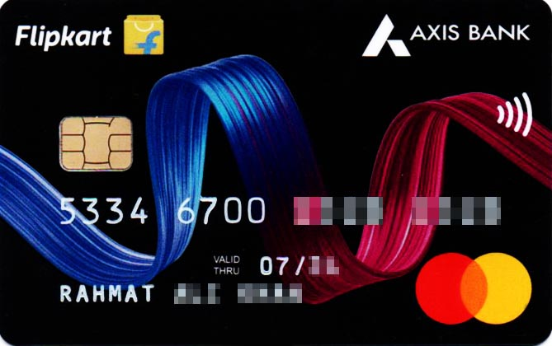

**Benefits of Axis Flipkart Credit Card**

* Earn 5% Unlimited Cashback on Flipkart spends.
* Earn 4% Cashback on Swiggy, Uber, PVR, Cleartrip, Curefit and Tata Play
* Get 1.5% Cashback on all other spends. Cashback will be credited directly in your credit card statement
* Enjoy 4 Complimentary lounge visits within India (4 Lounge access in a year)
* Get 1% fuel surcharge waiver on fuel purchases at all fuel stations across India. Valid on transactions between Rs 400 and Rs. 4000 only . Max. benefit upto Rs. 400 only. GST charged on fuel surcharge is non-refundable. No cashback on fuel transactions.
* Get Flipkart gift card worth Rs 500 on your first transaction with your Flipkart Axis credit card. (within 30 days of card issuance) (Not applicable for lifetime free cards)
* 50% instant discount up to Rs.100 on 1st Swiggy order. Use code 'AXISFKNEW' (This offer can be used once per Customer on their first transaction with the card) (Valid once per user). Read T&Cs at: https://www.axisbank.com/docs/default-source/default-document-library/welcome-benefits-swiggy.pdf

**How to Apply for Axis Flipkart Credit Card**

* User click on the CTA Button or tracking link
* He/She will be redirected to Axis website
* User Click Login/Join Now and do OTP verification
* Select Axis Flipkart Credit Card and provide the required details.
* His/her application will be submitted, and a confirmation SMS will be sent on approval of his/her application.
* User get application status within 10 minutes

**Documents required for the application**

* PAN card/Form 60
* ID proof
* Address proof
* Bank statement or Income Proof

**Eligibility Criteria**

* Employment status: Income- Salaried: Starting from Rs 21,000 and for Self Employed: Starting from Rs 30,000
* Age: 21-70 years
* Available across major cities in India

**Fees and List of all Charges**

* Joining Fees: Rs 500 + GST
* Annual Fees: Rs 500 + GST(waived on annual spends of Rs 3,50,000 or more)
* Interest rate: Up to 3.6% per month
* Cash Withdrawal Charges: 2.5% (min Rs 500)
* Card Replacement Charges: ~~Rs 100~~ Nil

**Important Information**

* If user’s Card is disbursed, you will be eligible for commission.
* No commission if Application is Rejected

Cashback earned will be deducted from user’s next month credit card statement